**Project 2**

**(Coffee Ordering System)**

**Objective:**

Create a simple **coffee ordering program** where users can select a type of coffee and optional add-ons. The program calculates and displays the total bill based on the user's selections.

**Requirements:**

1. **Coffee Selection:**
   * The user can choose from the following types of coffee:
     1. Espresso – ₹200
     2. Cappuccino – ₹250
     3. Latte – ₹300
   * If the user enters an invalid coffee option, display an **"Invalid choice"** message and end the program.
2. **Add-Ons:**
   * **Whipped Cream:** Optional for ₹30.
     1. Prompt the user: "Add whipped cream for ₹30? (yes=1 / no=0)"
     2. If the user selects **yes**, add ₹30 to the total price.
   * **Flavor Shot:** Optional (e.g., Vanilla for ₹20 or Hazelnut for ₹25).
     1. Prompt the user: "Add a flavor shot? (Vanilla for ₹20 or Hazelnut for ₹25) (yes=1 / no=0)"
     2. If the user selects **yes**, then ask for “Which one? (Enter 1 for Vanilla & 2 for Hazelnut)”
     3. If user selects Vanilla add ₹20 to the total bill and if user selects Hazelnut add ₹25 to the total bill.
3. **Total Calculation:**
   * After all choices are made, the program should display the **final total bill** to the user.

**Sample Output:**

**Run 1:**

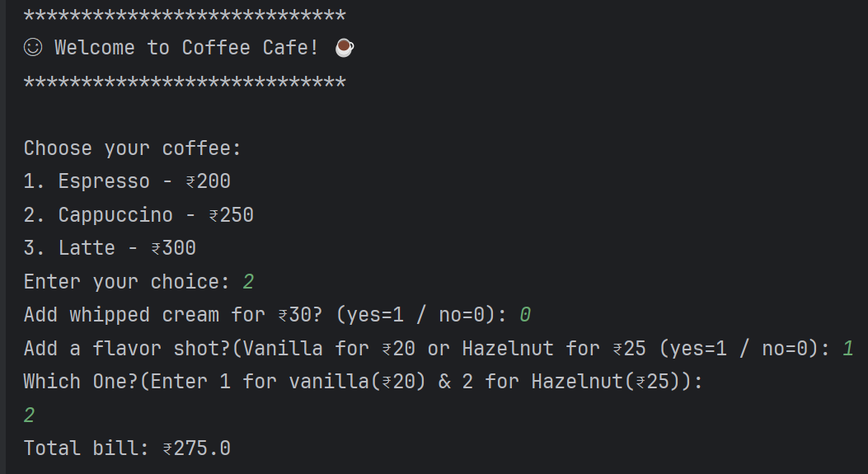

**Run 2:**

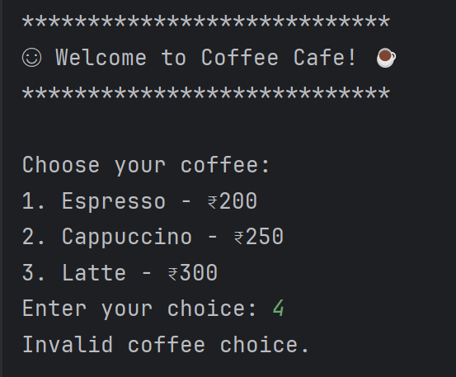

**Constraints:**

* Use **if-else and nested if statements** for decision-making.
* No loops should be used in the program.